Revista Mexicana de Ingeniería Química
Practical approach to identify electrochemical parameter in aqueous Potassium ferricyanide by solving the multi-variable Cottrell equation via genetic algorithms
Enfoque práctico para la identificación de los parámetros electroquímicos en una solución de ferrocianuro de potasio via algoritmos genéticos
W.J. Pech-Rodríguez^{1,2}*, F.J. Rodríguez-Varela¹, C.A. Calles-Arriaga³, E.N. Armendáriz-Mireles¹
¹Master Engineering Program, Polytechnic University of Victoria, Victoria city, Mexico.
²Sustentabilidad de los Recursos Naturales y Energía, Cinvestav Unidad Saltillo, Ramos Arizpe, México.
.Sent date: 6/7/2023

The supporting information document includes the following items: a screenshot of the Matlab Optimization Toolbox (Figure S1), the complete used code to solve the multi-objective Cottrell equation (Table S1), and the explained mechanism for ferricyanide reaction at the Pt surface (Figure S2).

Figure S1 display a screenshot for the Matlab Optimization Tool-box application. This platform offers practitioners a simple solution to solve several multi-objective optimization problems. In addition, users can define the solver and set of options. In this work, the genetic algorithm (GA) was chosen to solve the Cottrell equation considering three unknown variables. This app allows users to configure crossover, population size and stopping criteria easily.

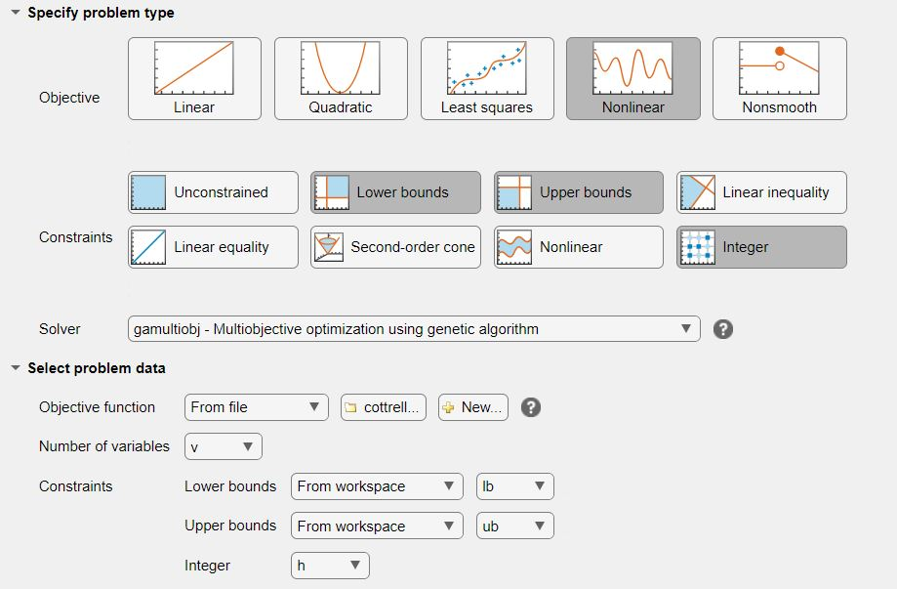

Figure S1. Matlab Optimization Tool-box for optimization

Table S1. Complete code to solve the multi-objective problem
function y=cottrell(x)
%C x(1)=n; x(2)=c; x(3)=D
F=96485;
A=0.1963;
t=0.315;
y(1)=min(abs((A.*x(1).*F.*x(2).*sqrt(x(3)))./(sqrt(pi.*t))-0.14383));
t=0.35;
y(2)=min(abs((A.*x(1).*F.*x(2).*sqrt(x(3)))./(sqrt(pi.*t))-0.1334));
t=0.416;
y(3)=min(abs((A.*x(1).*F.*x(2).*sqrt(x(3)))./(sqrt(pi.*t))-0.125));
t=0.479;
y(4)=min(abs((A.*x(1).*F.*x(2).*sqrt(x(3)))./(sqrt(pi.*t))-0.115));
t=0.58;
y(5)=min(abs((A.*x(1).*F.*x(2).*sqrt(x(3)))./(sqrt(pi.*t))-0.10));
t=0.68;
y(6)=min(abs((A.*x(1).*F.*x(2).*sqrt(x(3)))./(sqrt(pi.*t))-0.094));
t=0.8;
y(7)=min(abs((A.*x(1).*F.*x(2).*sqrt(x(3)))./(sqrt(pi.*t))-0.088));
t=0.93;
y(8)=min(abs((A.*x(1).*F.*x(2).*sqrt(x(3)))./(sqrt(pi.*t))-0.082));
t=1;
y(9)=min(abs((A.*x(1).*F.*x(2).*sqrt(x(3)))./(sqrt(pi.*t))-0.078));
t=1.12;
y(10)=min(abs((A.*x(1).*F.*x(2).*sqrt(x(3)))./(sqrt(pi.*t))-0.076));
t=1.29;
y(11)=min(abs((A.*x(1).*F.*x(2).*sqrt(x(3)))./(sqrt(pi.*t))-0.0679));
t=1.469;
y(12)=min(abs((A.*x(1).*F.*x(2).*sqrt(x(3)))./(sqrt(pi.*t))-0.06594));
t=1.99;
y(13)=min(abs((A.*x(1).*F.*x(2).*sqrt(x(3)))./(sqrt(pi.*t))-0.0576));
t=2.33;
y(14)=min(abs((A.*x(1).*F.*x(2).*sqrt(x(3)))./(sqrt(pi.*t))-0.053));
t=2.92;
y(15)=min(abs((A.*x(1).*F.*x(2).*sqrt(x(3)))./(sqrt(pi.*t))-0.047));
t=3.6;
y(16)=min(abs((A.*x(1).*F.*x(2).*sqrt(x(3)))./(sqrt(pi.*t))-0.0413));
t=4;
y(17)=min(abs((A.*x(1).*F.*x(2).*sqrt(x(3)))./(sqrt(pi.*t))-0.0413));
t=4.5;
y(18)=min(abs((A.*x(1).*F.*x(2).*sqrt(x(3)))./(sqrt(pi.*t))-0.039));
t=4.98;
y(19)=min(abs((A.*x(1).*F.*x(2).*sqrt(x(3)))./(sqrt(pi.*t))-0.03514));
end

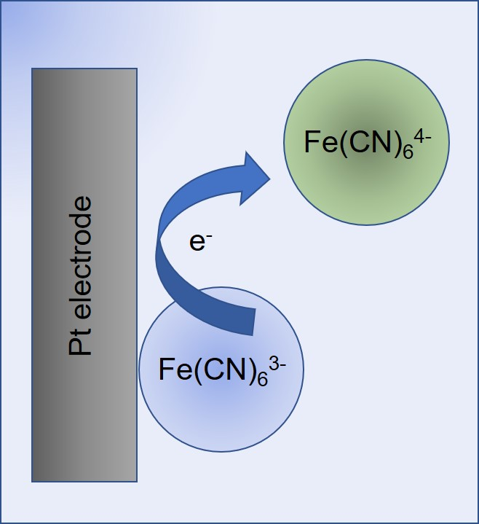
Figure S2. Schematic diagram of the proposed electron reaction of Fe(CN)₆³⁻ species at Pt surface

* W.J. Pech-Rodríguez. E-mail: wpechr@upv.edu.mx Tel.

