4. Supplementary material
Physicochemical data reported on unmodified agave fructans (NAF) and high- performance (HPAF) and high degree of polymerization (HPAF) fractions.
The use of NAF, HPAF and HDPAF has been studied by some authors, who have reported specific physicochemical characteristics. Table S1 shows some properties
Table S1. Characteristic of Agave tequilana fructans fractions as additives and wall material in the encapsulation.
Characteristic (g·100 g−1) | NAF | HPAF | HDPAF
Moisture | 4.62 ± 0.2 | 3.01 ± 0.03 | 2.52 ± 0.23
Ash | 0.1 ± 0.02 | 0.15 ± 0.05 | 0.1 ± 0.05
Total carbohydrate | 97.5 ± 1.7 | 98.2 ± 0.7 | 98.6 ± 0.5
Reducing sugars | 13.6 ± 0.5 | 0.8 ± 0.06 | 0.4 ± 0.04
Fructans | 83.9 ± 0.3 | 97.4 ± 0.5 | 98.2 ± 0.3
a_{w} | 0.41 ± 0.02 | 0.33 ± 0.001 | 0.3 ± 0.003
Enriched DP | ---- | 4–80 | 30–80
Tg (°C) | 52.68 | ---- | 130.05
HPAF= High Performance Agave Fructans; HDPAF= High Degree of Polymerization Agave Fructans and NAF= Native Agave Fructans.

Source: (Rodríguez-Furlán et al., 2014; Aldrete-Herrera, P.I., 2013; Ceja-Medina et al., 2020; Jimenez-Sánchez et al., 2019; Ramos-Hernández et al., 2021).

Table S2. Physicochemical properties of the capsules obtained by spray drying using HDPAF fraction as wall material in the encapsulation of a symbiotic

Property | Spray drying
L* | 87.61 ± 1.90
a* | 1.75 ± 0.03
b* | 7.14 ± 0.23
Hue angle | 85.43 ± 0.22
Chroma | 2.32 ± 0.04
Browning index (%) | 0.41 ± 0.02
Total color change | 6.52 ± 0.09
a_{w} | 0.050 ± 0.05
Moisture (%) | 3.27 ± 0.10

Source: Juárez-Trujillo et al., 2021

Table S3. Properties of stabilized pineapple powder based on NAF and MD
Treatment | Moisture (% | a_{w} | Solubility (%)
FT (%) MD (%)
0 10 | 2.94 ± 0.09 | 0.1823 ± 0.13 | 95.93 ± 0.03
2 10 | 2.82 ± 0.22 | 0.1579 ± 0.02 | 96.88 ± 0.08
4 10 | 2.74 ± 0.02 | 0.1423 ± 0.01 | 97.34 ± 0.18
FT: Fructans, MD: Maltodextrin.

Source: Jiménez-Sánchez et al., 2019

Table S4. Physicochemical characterization of the 70% high degree of polymerization agave fructans(HDPAF) polymer solution with and withoutβ-carotene

Parameter | 70% HDPAF without β-Carotene | 70% HDPAF with β-Carotene
Viscosity¹(Pa·s) | 3.69±0.05ª | 3.36±0.03ª
Surface tension (mN/m) | 30.1±0.1^{b} | 29.6±0.2^{b}
Electrical conductivity (mS/cm) | 5.54±0.01^{c} | 7.30±0.03^{c}
Different letters within the same row indicate significant differences among samples (α=0.05). The average values were obtained from the analysis of three replicas. ¹Viscosity values were read at a shear rate of 39.8 s−¹

Source: Cruz-Salas et al., 2019

Table S5. Physical properties (conductivity, surface tension, and viscosity) of solutions and emulsions at different high degree of polymerization Agave fructans (HDPAF) concentrations

Concentration (%w/w) | Viscosity (cP) | Surface Tension (mN/m) | Conductivity (μS/cm)
Solutions
5 | 1.61±0.05ª | 24.35±0.05ª | 69.39±0.03ª
10 | 2.37±0.07^{b} | 24.37±0.02ª | 82.14±0.03^{b}
20 | 3.42±0.01^{c} | 4.85±0.05^{b} | 101.20±0.05^{c}
30 | 6.82±0.02^{d} | 23.65±0.05^{c} | 93.30±0.06^{d}
40 | 46.05±0.05e | 23.51±0.05^{d} | 76.73±0.05e
50 | 162.22±0.60^{f} | 23.46±0.05^{d} | 52.86±0.01^{f}
Emulsions
5 | 2.65±0.03ª | 22.42±0.04ª | 41.81±0.04ª
10 | 3.40±0.03^{b} | 22.91±0.02^{b} | 45.82±0.04^{b}
20 | 8.83±0.08^{c} | 24.05±0.03^{c} | 52.70±0.02^{c}
30 | 12.26±0.09^{d} | 23.20±0.02^{d} | 0.89±0.02^{d}
40 | 45.70±0.12e | 22.73±0.03e | 39.11±0.04e
50 | 93.54±0.24^{f} | 21.13±0.03^{f} | 30.26±0.01^{f}
^{a–f:} Different superscripts within the same column indicate significant differences among the samples (p< 0.05).

Source: Ramos-Hernández et al., 2018

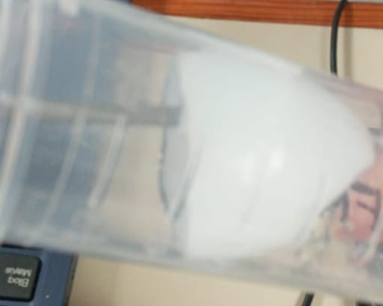
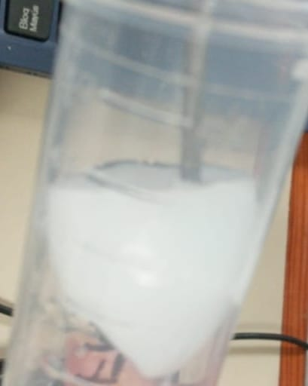
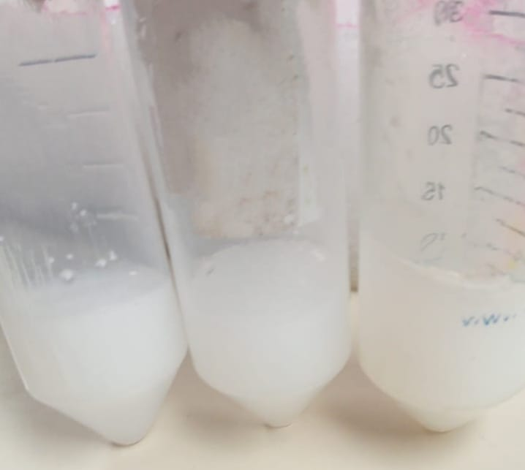

Figure S1. Gel-like appearance of the agave fructan fractions formed after acylation at pH 10

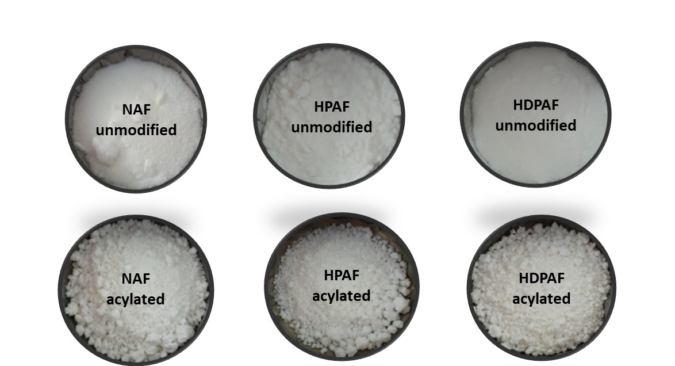

Figure S2. Agave fructans before and after acylation

References

Aldrete Herrera, P. I. (2013). Separación de una fracción de fructanos de Agave tequilana Weber variedad azul, con alto GP mediante filtración tangencial. Tesis de maestría en Ciencias en Alimentos, Instituto Tecnológico de Tepic, México.

Ceja-Medina, L.I., Ortiz-Basurto, R.I., Medina-Torres, L., Calderas, F., Bernad-Bernad, M.J., González-Laredo, R.F, Ragazzo-Sánchez, J.A., Calderón-Santoyo, M., González-Ávila, M., Andrade-González, I., and Manero, O. (2020). Microencapsulation of Lactobacillus plantarum by spray drying with mixtures of Aloe vera mucilage and agave fructans as wall materials. Journal of Food Process Engineering 43, e13436. https://doi.org/10.1111/jfpe.13436
Cruz-Salas, C.N., Prieto, C., Calderón-Santoyo, M., Lagaron, J.M., and Ragazzo-Sánchez, J.A. (2019). Micro- and Nanostructures of Agave Fructansto Stabilize Compounds of High Biological Valuevia Electrohydrodynamic Processing. Nanomaterials 9(12). https://doi.org/10.3390/nano9121659
Jimenez-Sánchez, D.E., Calderón-Santoyo, M., Herman-Lara, E., Gaston-Peña, C., Luna-Solano, G., and Ragazzo-Sánchez, J.A. (2019). Use of native agave fructans as stabilizers on physicochemical properties of spray-dried pineapple juice. Drying Technology. https://doi.org/10.1080/07373937.2019.1565575
Juárez-Trujillo, N., Jiménez-Fernández, M., Franco-Robles, E., Beristain-Guevara, C.I., Chacón-López, M.A., and Ortiz-Basurto, R.I. (2021). Effect of three-stage encapsulation on survival of emulsified Bifidobacterium animalis subsp. Lactis during processing, storage and simulated gastrointestinal tests. LWT – Food Science and Technology 137, 110468. https://doi.org/10.1016/j.lwt.2020.110468
Ramos-Hernández, J.A., Lagarón, J.M., Calderón-Santoyo, M., Prieto, C., and Ragazzo-Sanchéz, J.A. (2021) Enhancing hygroscopic stability of agave fructans capsules obtained by electrospraying. Journal of Food Science Technology 58, 1593–1603. https://doi.org/10.1007/s13197-020-04672-3
Ramos-Hernández, J.A., Ragazzo-Sánchez, J.A., Calderón-Santoyo, M., Ortiz-Basurto, R.I., Prieto, C., and Lagaron, J.M. (2018). Use of Electrosprayed Agave Fructans as Nanoencapsulating Hydrocolloids for Bioactives. Nanomaterials 8(11). https://doi.org/10.3390/nano8110868
Rodriguez-Furlán, L.T., Aldrete-Herrera, P., Pérez-Padilla, A., Ortiz-Basurto, R.I. and Campderrós, M.E. (2014). Assessment of agave fructans as lyoprotectants of bovine plasma proteins concentrated by ultrafiltration. Food Research International 56, 146–158. https://doi.org/10.1016/j.foodres.2013.12.014

