*Revista Mexicana de Ingeniería Química*

**Evaluation of the reaction capacity of early warning indicators to failures in biogas production systems**

**Evaluación de la capacidad de reacción de los indicadores de alerta temprana ante fallas en sistemas de producción de biogás**

P.M. Alvarado-Reyna1, A. Albalate-Ramírez1, E.E. García-Balandrán1, C. Escamilla-Alvarado1, U. Galván-Arzola1, L.R. Miramontes-Martínez2*, P. Rivas-García1[1]*

1*Centro de Investigacion en Biotecnologia y Nanotecnologia, Facultad de Ciencias Quimicas, Universidad Autonoma de Nuevo Leon. Parque de Investigacion e Innovacion Tecnologica, km 10 Highway to the International Airport Mariano Escobedo, zip 66629 Apodaca, Nuevo Leon, Mexico.*

2*Facultad de Agronomia, Universidad Autonoma de Nuevo Leon, Francisco Villa s/n, Fraccionamiento Ex Hacienda El Canada, zip 66050, Gral. Escobedo, Nuevo Leon, Mexico.*

Sent date: 19/April/2024

**Supplementary material**

Figure S1. RSD of biogas productivity. R1 in red and R2 in blue.

Table S1. Shewhart control parameters.

|  |  |  |  |  |  |
| --- | --- | --- | --- | --- | --- |
| EW | Reactor | µ | σ | LCL | UCL |
| d(%CH4/%CO2)/dt | R1 | 0.04 | 0.39 | -1.12 | 1.2 |
|  | R2 | 0.04 | 0.35 | -1 | 1.08 |
| d(VFA)/dt | R1 | -8.1 | 85.21 | -263.72 | 247.52 |
|  | R2 | -6.75 | 92.3 | -283.67 | 270.16 |
| d(VFA/TA)/dt | R1 | 0 | 0.02 | -0.08 | 0.07 |
|  | R2 | -0.01 | 0.02 | -0.07 | 0.06 |
| d(IA/PA)/dt | R1 | -0.02 | 0.04 | -0.15 | 0.1 |
|  | R2 | 0.01 | 0.03 | -0.07 | 0.09 |
| d(Productivity/VFA)/dt | R1 | -3.01x10-5 | 6.51x10-5 | -2.25x10-4 | 1.65x10-4 |
|  | R2 | -3.69x10-10 | 1.29x10-9 | -4.23x10-9 | 3.49x10-9 |

|  |  |
| --- | --- |
|  |  |
|  |  |
|  |  |
|  |  |

Figure S2. Shewhart control charts for the EWs of R2.

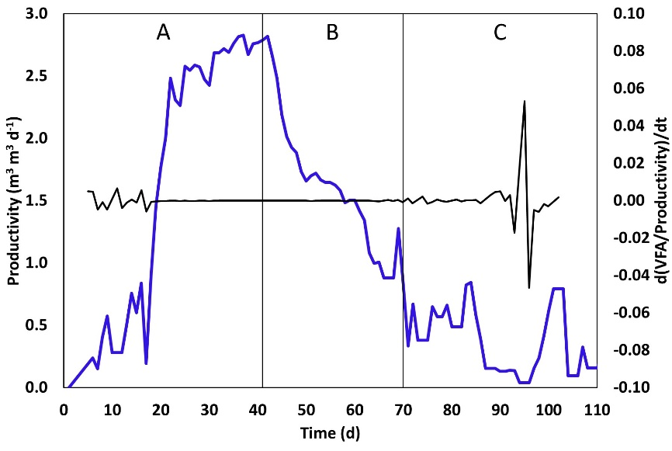

Figure S3. Behavior of the relationship between VFA and biogas productivity proposed as EW for R2.

1. *\*Corresponding author. E-mail:* [*luis.miramontesmr@uanl.edu.mx*](mailto:luis.miramontesmr@uanl.edu.mx) *and* [*pasiano.rivasgr@uanl.edu.mx*](mailto:pasiano.rivasgr@uanl.edu.mx)

   *Tel. 81 8329 4000 ext. 6281*